Greater Manchester Diabetes Clinical Network

Annual Diabetes Review

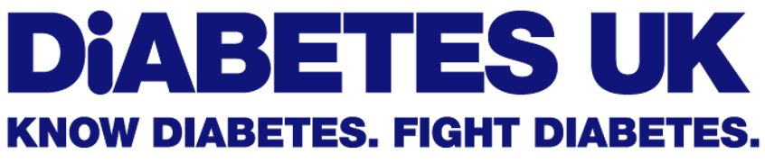
Guidance for healthcare assistants and other appropriately trained staff on contacting patients living with type 2 diabetes to discuss care and review requirements during the COViD-19 pandemic.

Reproduced from original information produced by Diabetes UK and published with their kind permission

Annual diabetes reviews: Advice for patients

You need certain health checks when you have diabetes. You might hear this called your annual review, but you don’t always get these once a year.

During the coronavirus pandemic, your diabetes care is going to look a bit different for a while. Here’s what to expect.

What diabetes care can I expect?

When you have diabetes, you’re entitled to certain checks, tests and services to help you get the care you need – like your HbA1c blood test. These checks help to prevent serious diabetes complications, like problems with your feet, eyes, heart and kidneys.

During coronavirus, many routine appointments like your annual diabetes review have been cancelled or postponed. We know this may be worrying, but you should be able to reschedule as things get back to normal. In some areas, these appointments are being held over the phone or by video call instead.

Some people with diabetes who have more urgent care needs are being prioritised, for example if you’re already having treatment for a foot or eye problem, or if you’re pregnant. If you are invited to an appointment in person, your healthcare professionals will be wearing protective equipment and appointments will be scheduled to avoid busy waiting areas. It's really important you go to your appointment.

It's important the doctor or team responsible for your diabetes care keep you updated on what to expect right now and explain when your next review will be. If you're worried or have questions, contact them to find out more.

Blood tests

We know that some people with diabetes may not have been able to get their HbA1c, cholesterol, and kidney function blood tests right now. But some hospitals and general practices are collecting samples for HbA1c by post or by drive-through services.

If you have not had a blood test in the last year and you are worried, ask your healthcare team for a test.

And if you use a flash glucose monitor or continuous glucose monitor, you should be able to share your time in range readings with your clinical team, pre-empting the need for an HbA1c test.

Blood pressure checks

If you don’t have high blood pressure, then you probably won’t be invited to a blood pressure check for some time. But if you are invited for a blood test, ask if your blood pressure can be taken at the same time.
In some areas, diabetes care teams have suggested people buy their own home blood pressure monitoring kit. You can find a list of blood pressure monitors to use at home from the British and Irish Hypertension Society website.

We know that won’t be possible for everyone, and we don’t think people should have to pay for these devices. We’re calling on the NHS to find other ways to make these available for free.

Foot checks

As with other routine diabetes care, foot services may be prioritising those at most risk. So if you don’t have any current problems with your feet, you may be waiting a little longer. However, it’s important your diabetes team let you know when to expect a check.

It’s never been more important to check your feet and legs – here we show you how to do it and what to look for. If you spot something new you're concerned about, like a cut or blister on your foot, call your GP practice and explain your situation. If you can't get through, call 111 for advice.

Eye screening

Eye screening has been restarted in some areas, but will have reduced capacity to ensure it is delivered safely. This means that appointments will be prioritised to those most at risk of experiencing sight loss, including:

- pregnant women
- people who already have eye problems (background or more advanced retinopathy)
- those who have recently been diagnosed
- if you haven't had any screening in the past.

If you are invited to a screening appointment it’s really important you go. And if you notice any changes to your eyesight, these should be checked as soon as possible – gradual changes can be checked by your optician, but if you notice any sudden changes get urgent medical care.

If your most recent screening test result showed no signs of retinopathy, this means you are in the group of people with diabetes who are lowest risk of retinopathy. Evidence gathered over several years shows it is now safe for you to wait up to 24 months between screening appointments. There is very little chance you will develop sight-threatening retinopathy between appointments.

Managing your diabetes between appointments

It makes all the difference if you’re in the know about your diabetes too. There are lots of things you can do to look after yourself at home, like eating a healthy diet to help manage your cholesterol and blood pressure, checking your feet daily for any changes, and keeping active.

And it’s not just about looking after your body – you’ll need to think about your emotional health too.

Discover how to look after your diabetes with confidence, in our free Learning Zone, with interactive quizzes and expert advice from healthcare professionals.

Owning your own care puts you in the driving seat. It’s how you manage your diabetes and how you reduce your risk of serious diabetes complications.

If you’re already having treatment

If you're already having treatment for something like a foot or eye problem, and you don't have coronavirus symptoms, then your appointments should still carry on. If you're worried about going to your clinic or hospital at this time or want to check whether your appointment is still going ahead, contact your diabetes team or call the number on your appointment letter. Take a look at our guide to going into hospital.
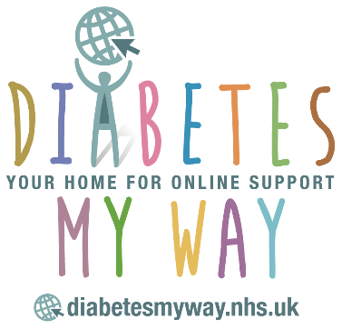
Personalised patient support in Greater Manchester

People living with diabetes in Greater Manchester can access more information at Diabetes My Way (https://diabetesmyway.nhs.uk/). Most can also register here to access their own personal diabetes data dashboard populated with the latest clinical information from their own GP’s. Information is also provided on services in each council area in Greater Manchester.

